

* My Child(ren) will be attending Lomira School District Summer School June 9th – July 3rd
  + I need before Summer School care
  + I need after Summer School care (a cold lunch is required)
* I am enrolling my child(ren) in Quad Care Swimming Lesson at the FDL Aquatic Center
  + Dates: June 10th, 12th, 17th, 19th, 24th, 26th Bus leaves at 12:30pm Lessons: 1pm-2pm

Please Highlight the days your child(ren) will be attending Jr. Summer Camp Quad

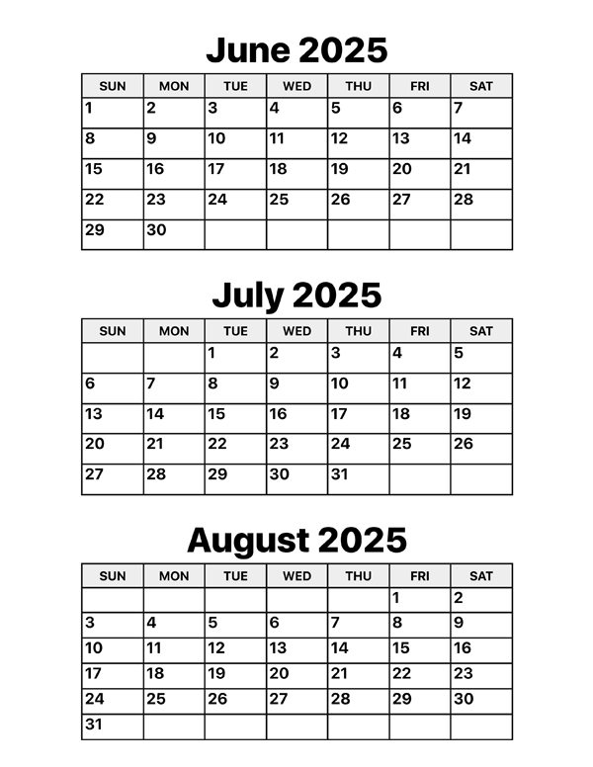

\*Children will only be charged for scheduled days